**Team Skeever Developer’s Manual**

Environment Setup:

Platform: Unity

Version: 2020.1.3f1

Download Link: <https://store.unity.com/download>

Unity Installation Instructions:

1) Begin by visiting <https://unity3d.com/get-unity/download> and clicking on “Choose Your Unity + Download”.

2) Next, select “Individual” and press “Get started” under “Personal”.

3) Under “First-time users,” press “Start here”.

4) Wait for the UnityHubSetup executable to download, and then click on it to run.

5) Accept the terms of agreement, continue to follow the instructions and press “next” before finally reaching the “Finish” button and clicking on it.

6) When Unity Hub opens, select a path and click “INSTALL”.

7) Then create a Unity ID or login.

8) Press continue and wait for Unity to download.

9) Unity Hub is now installed.

Context Diagram:

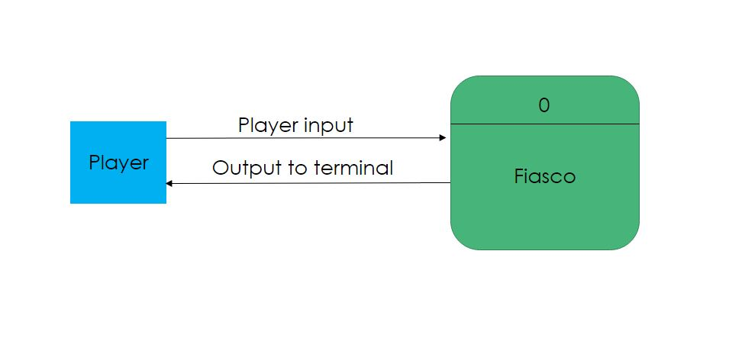

Class Diagrams:

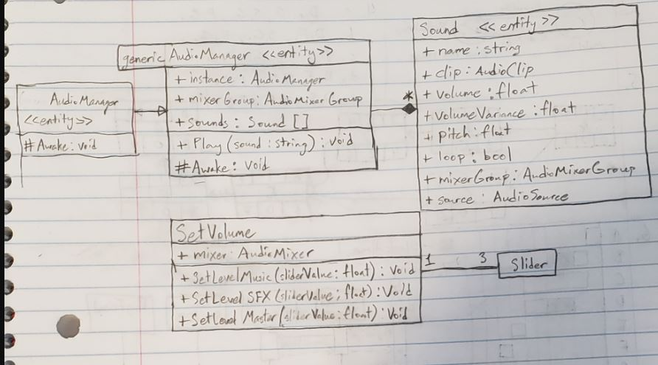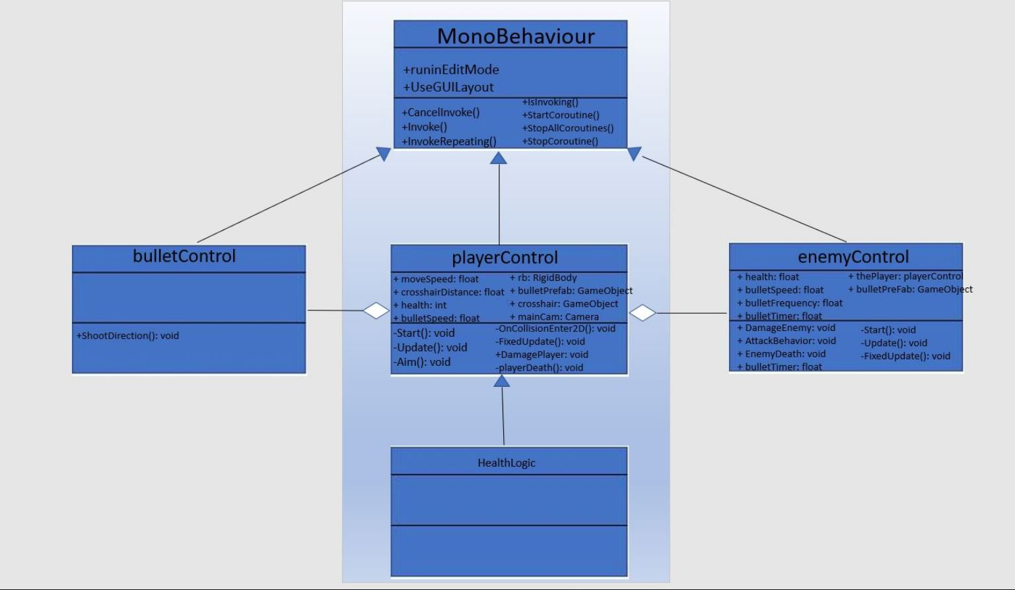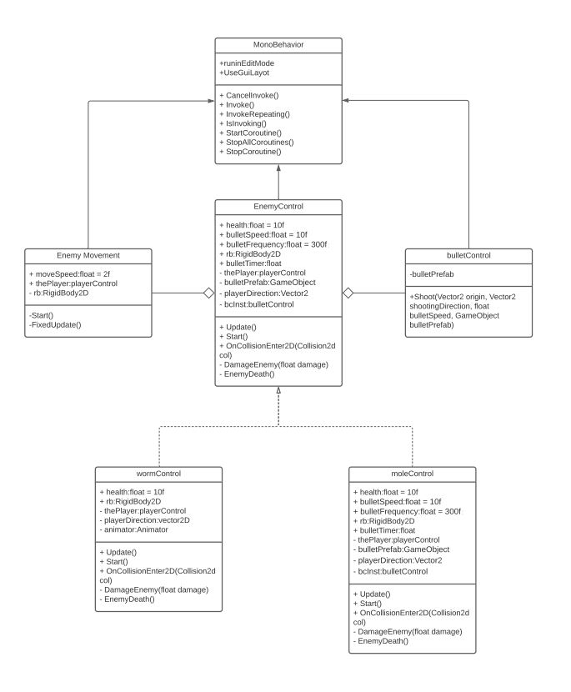

Prefab Creation Instructions:

1. Create a GameObject in the scene.
2. Drag the GameObject from the Hierarchy tab into the Project tab.

Patterns:

Various patterns can be found by searching online or by checking directly on the CS383 BBLearn page. If you prefer to look through the patterns described on BBLearn for this course, you’ll want to click on “Part 2: Individual – Plan Driven Design” on the left. Then, scroll down until you see the folder called “Patterns GRASP and GOF - Weeks 11 - 12 "ish" and open it. You should now see explanations of lots of different patterns in PDF form.

To choose an appropriate pattern more effectively, try to choose one that fits your coding standards and the general coding style of your group members.